PROTOCOL TITLE: Kidney and Pancreas Post Transplant: COVID-19 Vaccination Guidelines for Post-Transplant Patients
APPLICABLE FACILITIES:
☐EHC ☐EDH ☐EHH ☐EHI ☐EHN ☐EJCH ☐ELTAC ☒ESJH
☒EUH ☐EUHM ☐EUHS ☐EUOSH ☐EWWH ☐RJV-ERH ☐RJV-ESOP ☐TEC/ESA
EFFECTIVE DATE: 11/10/2021 | ORIGINATION DATE: 10/6/2021
CATEGORY: Diagnostic/Therapeutic/Preventive Medication Guidelines

LEVEL: Independent

SCOPE: All transplant program physicians, practitioners and clinical staff members are responsible for compliance with this clinical protocol.

PURPOSE: Immunocompromised patients are vulnerable to COVID-19 infection. Studies indicate some immunocompromised people don’t always build the same level of immunity after vaccination and may benefit from an additional dose to ensure adequate protection against COVID-19.

Vaccine Guidelines-

Vaccine Type | Vaccination Series |  |  | Booster
 | 1st dose | 2nd dose | 3rd dose
Pfizer-BioNTech | 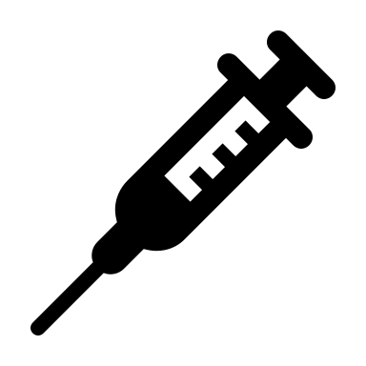 | 21 days after 1st dose | 28 days after 2nd dose | 6 months after 3rd dose
Moderna |  | 28 days after 1st dose | 28 days after 2nd dose | 6 months after 3rd dose
J&J |  | NA | NA | 2 months after 1st dose

Special Patient Population
- Fresh transplant patients:
- If unvaccinated pre-transplant, they are eligible to start the vaccination series 3 months after transplant
- If vaccinated with Pfizer pre-transplant, they are eligible to continue vaccination series and/or get the booster 3 months after transplant

- Patients with recent rejection:
- Patients who received Thymoglobulin are eligible to start the vaccination series and/or get the booster 3 months after the last dose of Thymoglobulin
- Patients who received IVIG are eligible to start the vaccination series and/or get the booster 2 weeks after the last dose of IVIG
- Patients who received Plasmapheresis are eligible to start the vaccination series and/or get the booster anytime

- Patients who receive Rituximab are eligible to start the vaccination series and/or get the booster after 4 weeks after the last dose of Rituximab

- Patients who receive eculizumab are eligible to start the vaccination series and/or get the booster anytime

- Patients who recovered from COVID-19 infection:
  - If they received Monoclonal Ab, they are eligible to start the vaccination series and/or get the booster 3 months after the last dose of Monoclonal Ab
  - If they received Remdesivir and dexamethasone, they are eligible to start the vaccination series and/or get the booster anytime
We advise immunocompromised patients to maintain personal measures to try to minimize exposure to COVID-19 (e.g., masking, distancing, avoiding crowds when possible) even after they are fully vaccinated because of the potential for reduced vaccine effectiveness. Household and other close contacts of immunocompromised patients should be vaccinated.

.
RELATED POLICIES / PROCEDURES:
Kidney and Pancreas Post-Transplant Management Care

DEFINITIONS: N/A

REFERENCES AND SOURCES OF EVIDENCE:
- https://www.cdc.gov/vaccines/covid-19/index.html
- Antibody Response After a Third Dose of the mRNA-1273 SARS-CoV-2 Vaccine in Kidney Transplant Recipients With Minimal Serologic Response to 2 Doses. Benotmane I, Gautier G, Perrin P, Olagne J, Cognard N, Fafi-Kremer S, Caillard S, JAMA. 2021
- Randomized Trial of a Third Dose of mRNA-1273 Vaccine in Transplant Recipients.
Hall VG, Ferreira VH, Ku T, Ierullo M, Majchrzak-Kita B, Chaparro C, Selzner N, Schiff J, McDonald M, Tomlinson G, Kulasingam V, Kumar D, Humar A -N Engl J Med. 2021

KEY WORDS:

