Pre-Renal Transplant Surgery Consult:
1. Established visit (previously seen by APP) -
a. You will see that a problem list and allergies were added (before medication list)
b. In order to bill at a Level 4, must use “25 minutes of which 50% was for consult” (added as a banner)
c. “I have assessed all of the above diagnoses and taken into consideration for transplant” should be added to each note

2. Consult visit (Outreach clinic) –
a. You will see that a problem list and allergies were added (before medication list)
b. In order to bill at a Level 4, must use “45 minutes of which 50% was for consult” (added as a banner)
c. “I have assessed all of the above diagnoses and taken into consideration for transplant” should be added to each note

Post-Renal Transplant Note (Immunosuppression):
1. Outpatient –
a. Always add modifier 24 for immunosuppression (in order to bill outside of the 90 day global period)
2. Inpatient -
a. Auditors look for both the impression and plan. Rachel has added an impression and plan to the immunosuppression diagnosis. In addition for all other diagnoses, the format will be changed to have a separate category for each system with an impression and plan that will need to be filled out in order to capture billing.

In the screen shot example listed below, the diagnoses were bypassed and a list of systems were then free texted. As you will notice there is very little impression for each of the systems and mostly plans. We would not be able to capture all of the charges for this note as written.
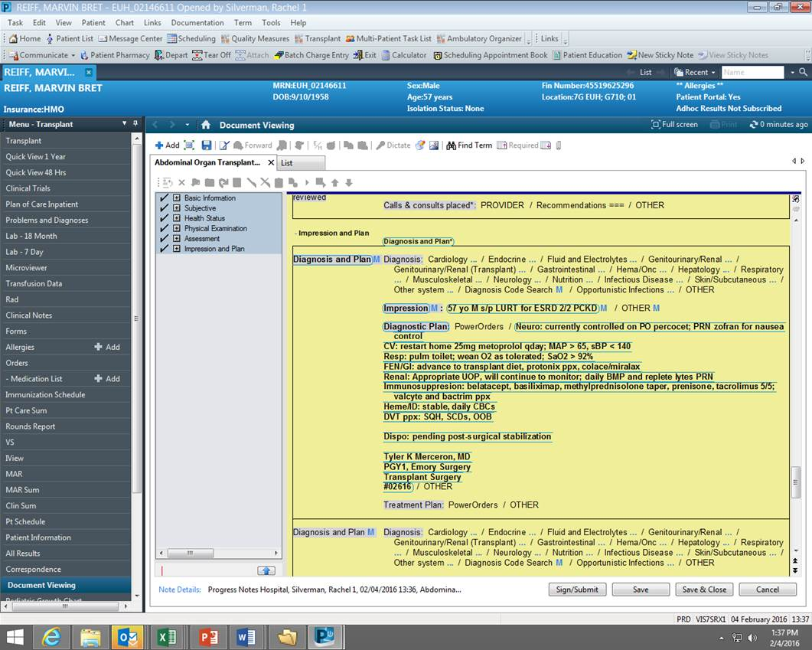

b) Therefore, for example, documentation should follow:
Cardiology
-Impression
-Plan
Endocrine
-Impression
-Plan
Etc.

