PROTOCOL TITLE: Kidney and Pancreas Post-transplant Cardiovascular Risk Reduction
APPLICABLE FACILITIES:
☐EHC ☐EDH ☐EHH ☐EHI ☐EHN ☐EJCH ☐ELTAC ☒ESJH
☒EUH ☐EUHM ☐EUHS ☐EUOSH ☐EWWH ☐RJV-ERH ☐RJV-ESOP ☒TEC/ESA
EFFECTIVE DATE: | ORIGINATION DATE: 6/27/2018
CATEGORY: Diagnostic/Therapeutic/Preventive

LEVEL: Independent

SCOPE:
The Emory Transplant Center Kidney-Pancreas Transplant Program will strive to reduce cardiac risk in all kidney-pancreas transplant recipients. Kidney-pancreas transplant recipients are at a high risk for cardiovascular events following transplant. Cardiovascular disease is the leading cause of morbidity and mortality post transplantation. Risk factors include: Age>40, male, race, hypertension, hyperlipidemia, prior cardiac events, diabetes, obesity, metabolic syndrome, albuminuria and smoking. Reduction of cardiovascular risks requires accurate risk assessment as well as appropriate pharmacological and non-pharmacological interventions.

GUIDELINES:

The purpose of this guideline is to address the practical management of kidney-pancreas transplant patients with hypertension, dyslipidemia and cardiovascular disease.

- Diet and Lifestyle Modifications: All kidney-pancreas transplant patients are encouraged and instructed on a healthy lifestyle including weight reduction if overweight, moderate sodium restriction (2,000 to 2,400 mg sodium daily), regular physical activity, and moderation in alcohol consumption. We strongly recommend smoking cessation. Nutrition support and lifestyle modification counselling will be provided to all kidney transplant recipients.

- Hypertension Control: Hypertension occurs in a majority of patients with chronic kidney disease and usually persists after successful kidney transplantation. Less stringent blood pressure control targets (<150/90 mmHg) is recommended in the first month after renal transplant to avoid hypotension and graft thrombosis.

BP goals:

- 1 month: Aim for BP <150/90
- 2 months onward; Aim for BP <130/80.

Choice of agents: The choice of initial antihypertensive agent may be determined by the presence of one or more common post-transplant complications that may be made better or worse by specific antihypertensive agents.

- First choice agents: Beta blockers, Calcium channel blockers (dihydropyridine*)

- Patients with proteinuria or diabetes: ACE inhibitors or ARBs**.

- Patients with CHF and low ejection fraction: ACE inhibitors and ARBs, beta blockers, hydralazine and oral nitrates.

- Patients with polycythemia: ACE inhibitors

- Additional agents: Diuretics [furosemide, bumetanide, torsemide], hydralazine, minoxidil, clonidine, doxazosin, terazosin.

*Non-dihydropyridine calcium channel blockers (diltiazem, verapamil) should be used cautiously due to interactions with calcineurin inhibitors and mTor inhibitors, and reserved for those needing them for rate control or angina.

** Given the increased risk of fluctuating GFR, AKI, hyperkalemia would avoid ACE inhibitor/ARB in the 1st month post-transplant.

- Dyslipidemia Management: We recommend monitoring of lipid panel at 0, 3, 6, 12 months in the 1st year post post-transplant and then on an annual basis.

Statins are the cornerstone of therapy, in addition to healthy lifestyle interventions, for dyslipidemia management. The intensity of statin therapy is divided into 3 categories: high-intensity, moderate-intensity, and low-intensity.

We recommend starting on the lowest recommended dose and uptitrate to maximum dose based on discussion with nephrologist and clinical pharmacist.

 | LOW INTENSITY STATIN | MODERATE INTENSITY STATIN | HIGH INTENSITY STATIN
LDL LOWERING | <30% | 30-50% | >50%
 | Pravastatin 10-20mg*  Simvastation 10mg  Lovastatin 20 mg  Fluvastatin 20-40 mg | Atorvastatin 10-20mg*  Rosuvastatin 5-10mg*  Simvastation 20-40mg  Pravastatin 40-80mg  Lovastatin 40 -80mg  Fluvastatin XL 80 mg  Fluvastatin 40 mg BID  Pitavastatin 1–4 mg | Atorvastatin 40-80mg*  Rosuvastatin 20-40mg*
*Recommended Statins to use

- Diabetes Management: Many patients develop diabetes mellitus following kidney transplant which increases their cardiovascular risks. In addition to diet and lifestyle modifications, pharmacological interventions can be used to keep hemoglobin A1c less than 6.5.

- Primary Prevention of Cardiovascular Disease: All kidney-pancreas transplant recipients are at risk of having atherosclerotic cardiovascular disease. Therefore primary prevention is necessary for this group. Atherosclerotic Cardiovascular Disease (ASCVD) risk score should be calculated in all kidney transplant patients aged 20-79, without ASCVD, with LDL <160, who are not on a statin.
The ASCVD risk calculator can be found at:
http://tools.acc.org/ldl/ascvd_risk_estimator/index.html#!/calulate/estimator/
- Patients with severe hypercholesterolemia (LDL >190mg/dl) and adults 40 to 75 years of age with diabetes mellitus are candidates for immediate statin therapy without further risk assessment.
- Adults with diabetes mellitus should start with a moderate-intensity statin, and as they accrue multiple risk factors, a high-intensity statin may be indicated.
- All patients should be on 81mg dose of Aspirin at 1 month post-transplant unless contraindicated.
Primary dyslipidemia management guideline should be followed as shown below:
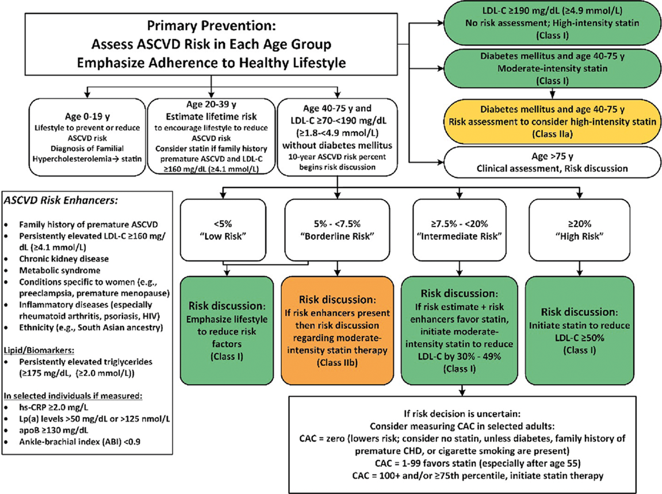

Source: 2019 ACC/AHA Guideline on the Primary Prevention of Cardiovascular Disease
- Secondary Prevention of Cardiovascular Disease: High-intensity statin therapy, if tolerated, is indicated if patient has clinical ASCVD (i.e. ACS, those with history of MI, stable or unstable angina or coronary or other arterial revascularization, stroke, TIA or PAD including aortic aneurysm, all of atherosclerotic origin).
- If LDL-C levels remains ≥70 mg/dL (≥1.8 mmol/L) on maximally tolerated statin therapy, adding ezetimibe may be reasonable.
- Low dose Aspirin is recommended for secondary prevention of ASCVD.

RELATED POLICIES / PROCEDURES: N/A

DEFINITIONS: N/A

REFERENCES AND SOURCES OF EVIDENCE:

ASCVD Risk Estimator:
http://tools.acc.org/ldl/ascvd_risk_estimator/index.html#!/calulate/estimator/

Donna K. Arnett. Circulation. 2019 ACC/AHA Guideline on the Primary Prevention of Cardiovascular Disease: A Report of the American College of Cardiology/American Heart Association Task Force on Clinical Practice Guidelines, Volume: 140, Issue: 11, Pages: e596-e646, DOI: (10.1161/CIR.0000000000000678)

Scott M. Grundy. Circulation. 2018 AHA/ACC/AACVPR/AAPA/ABC/ACPM/ADA/AGS/APhA/ASPC/NLA/PCNA Guideline on the Management of Blood Cholesterol: A Report of the American College of Cardiology/American Heart Association Task Force on Clinical Practice Guidelines, Volume: 139, Issue: 25, Pages: e1082-e1143, DOI: (10.1161/CIR.0000000000000625)

KEY WORDS: cardiovascular risk, atherosclerosis, hypertension, dyslipidemia, cholesterol, diabetes

